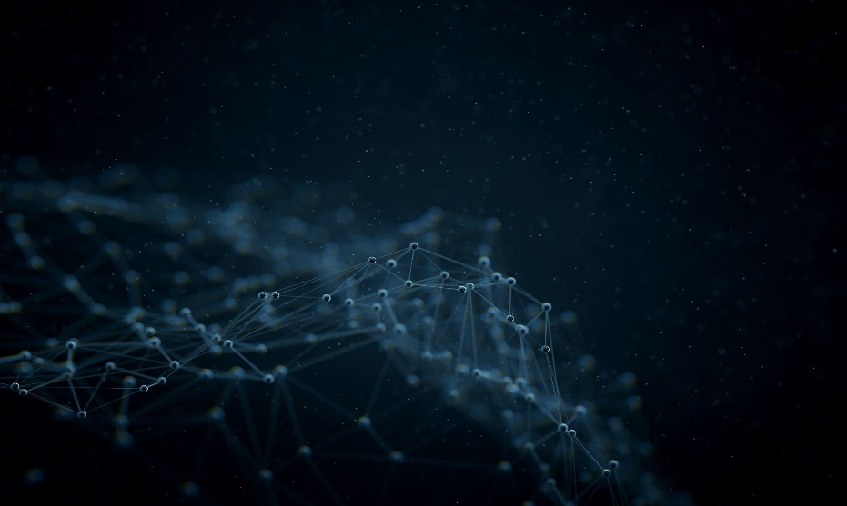[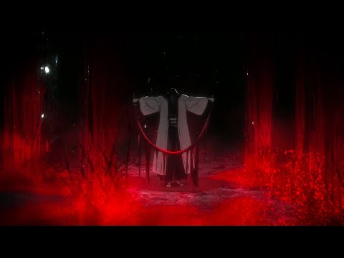](https://www.youtube.com/embed/1yuI5LX8hI4?feature=oembed)

|  |  |  |
| --- | --- | --- |
|  |  |  |
|  |  |  |
|  |  |  |
|  |  |  |

